**100071011 Computer Networks 2023-2024-2**

**Project-2**

**Building a CGI-Support Multi-Threaded Web Server**

**Specification**

|  |  |
| --- | --- |
| **学号 (Student ID)** | **1120212831** |
| **姓名 (Name)** | **刘东洋** |
| **班号 (Class No.)** | **07152102** |
| **授课教师 (Instructor)** | **阮思捷** |

**School of Computer**

**Beijing Institute of Technology**

**Jun 16, 2024**

1. **Requirement Analysis**

**1.1 Requirement**

This project involves building a multi-threaded web server that supports CGI testing. The server is designed to concurrently handle multiple service requests, delivering both static and dynamic web pages to web browsers for testing purposes.

**1.1.1 HTTP**

The server operates under the HTTP 1.0 protocol, issuing separate HTTP requests for each component of a webpage. This multi-threaded server is capable of processing GET, POST, and HEAD requests from clients. It must also return appropriate HTTP status codes including 200 (OK), 400 (Bad Request), 403 (Forbidden), and 404 (Not Found), complete with a corresponding message body in the response.

**1.1.2 Ports and Addresses**

The server is designed to manage several service requests simultaneously. It listens on a designated port via the main thread. Upon receiving a TCP connection request, it sets up a connection on an alternate port and assigns the request to a new thread dedicated to handling that specific connection.

**1.1.3 Max Connections and Thread Pool**

The server limits the number of simultaneous connections to a predefined maximum (maxConnections). If this threshold is exceeded, the server begins to terminate the oldest connections, along with their corresponding worker threads. The server maintains a balance between the number of worker threads and active requests: excess threads wait for new requests, while excess requests are buffered until threads become available.

**1.1.4 CGI**

The Common Gateway Interface (CGI) is employed to facilitate the creation of dynamic web pages, providing a versatile platform for web development.

**1.1.5 Log File**

The server is equipped with logging capabilities to record all server activities. The log is maintained as a straightforward text file, where each line documents a single request or 'hit', capturing detailed information about each interaction with the server.

**1.1.6 Performance Analysis**

Performance metrics such as throughput and response time are assessed using load and stress testing tools like http_load and webbench. These tests are crucial for optimizing server performance and ensuring reliable service delivery under varying loads.

**1.2 Analysis**

**1.2.1 TCP Socket**

In this project, the connection between our client and server is a TCP connection, which is connection-oriented, stream-oriented, and provides high reliability services. Both sending and receiving ends must have a corresponding pair of sockets. TCP sockets are the underlying principle for connections in this project.

**1.2.2 Thread Pool Management**

As a server, It should respond to each client request by creating a new thread, ensuring concurrent execution of all client tasks. However, considering the limited server load capacity, We cannot create threads indefinitely. Therefore, I need to release resources that are not in use for a long time to serve subsequent users. I have designed a thread pool to manage all client threads uniformly.

The thread pool itself also runs as an independent thread but is set as a daemon thread. This is a special process that runs in the background and performs specified tasks periodically. In each cycle, I create client threads that join the thread queue. When the number of client threads reaches the server's maximum capacity, I destroy the oldest client threads in the queue to free up resources for subsequent users.

**1.2.3 HTTP Request and Response**

A critical aspect of the server is handling requests and returning responses. The primary tasks in processing an HTTP request involve accepting data transmitted through the socket, converting it into recognizable UTF-8 encoded text. The request type (GET, POST, or HEAD) is then determined based on the header, directing it to the respective handling method, which then fetches and returns the corresponding response data based on the requested resource address.

**1.2.4 Static and Dynamic Page**

This section primarily deals with the implementation of the system's user interface through CSS and HTML.

The focus is on web pages, including interfaces for a calculator and database queries.

The web interfaces are designed using CSS and HTML.

**1.2.5 CGI**

CGI handles forms submitted by web pages, including hostnames and ports. The form content includes operands and operators for calculations or criteria for queries, handled by different modules. Cal.py is responsible for calculations, performing operations based on the operator and then displaying the results on the web page. Query.py handles database queries, crafting SQL statements based on the query criteria, executing these via cursor.execute(), and displaying the results on the web page.

**1.2.6 Log File**

Log functionality is indispensable in a server. Log files record messages related to TCP events and the handling of error events, playing a critical role in processing historical data, diagnosing issues, and understanding system activity. In this project, log files are generated with each server startup, and each record in the log comes from data received via the socket.recv() function from the connected sockets.

1. **Design**

This section details the design process, particularly focusing on establishing a TCP socket connection.

**2.1 TCP Socket**

The steps to establish a TCP-socket connection are as follows:

1. **Create a Socket:** Use socket() to create a socket.
2. **Bind:** Use bind() to bind it to a local IP address and port information.
3. **Listen:** Make the socket passive and able to accept connections with listen(), allowing it to receive incoming connections.
4. **Accept Connection:** Use accept() to wait for client connections. When a new client connects to the server, a new socket is generated specifically to serve that client.
5. **Receive Data:** Use recv() to receive data sent by the client.

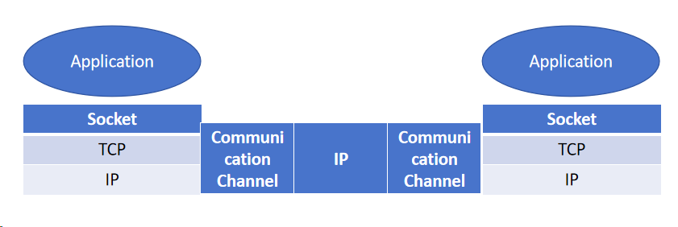

Fig1.TCP/IP network model

**2.2 Thread Pool (Connection Timeout Handling)**

The process related to thread pool management is depicted in the class diagram and flowchart below.

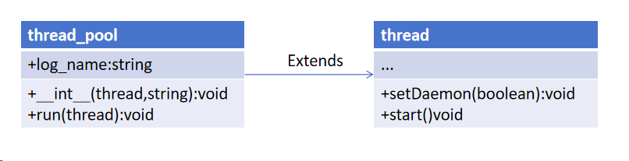

Fig2.Thread Pool Class Diagram

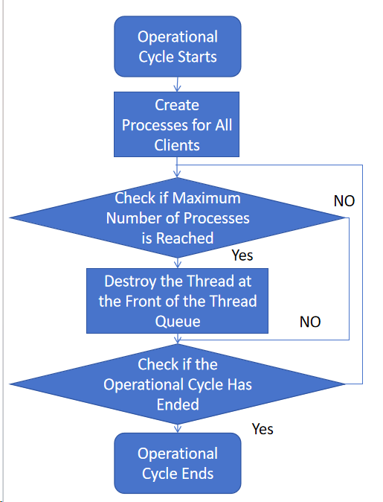

Fig3.translates to "Thread Pool Management Flowchart

The general workflow of thread pool management is as follows:

1. **Initialization:** The server creates a thread pool and automatically invokes the __init__() function to initialize the thread pool, starting its operational cycle.
2. **Running Tasks:** Threads within the thread pool invoke the run() function periodically to commence management tasks.
3. **Worker Instantiation:** For each request, a worker class instance is created, and an access thread is established for each client.
4. **Capacity Check:** The thread pool checks if the number of threads has reached its maximum capacity. If it has, the thread at the front of the queue is terminated to release resources and corresponding logs are generated. If not, no action is taken.
5. **Cycle Completion:** If the operational cycle is complete, the cycle ends; otherwise, the process returns to the capacity check step and continues as described.

**2.3 CGI**

The CGI for the calculator and the database query are detailed in the flowchart below:

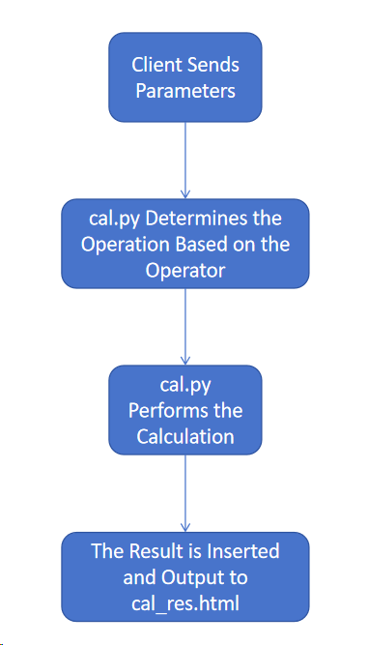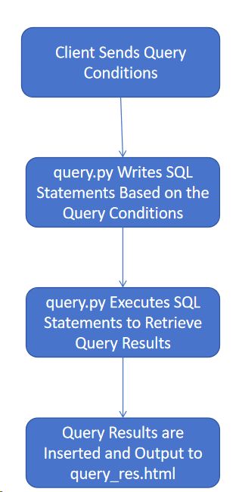

Fig4-5.Details of the CGI for the calculator and the database query

1. **Calculator Test:** Implemented in Python, the calculator reads the incoming parameters, adds them, modifies the template file, and returns the generated page to the Post thread.
2. **Database Query Test:** Implemented in Python, this functionality queries a student database which includes student names, student IDs, and classes. It supports queries based on three attributes; however, queries can also be conducted using just one or two of these attributes.
3. **Development and Implementation**

**3.1 Web Server and TCP Socket**

This module is developed in Python using PyCharm. Key code snippets and their explanatory comments are presented as follows:

|  |
| --- |
| server_socket = socket.socket(socket.AF_INET, socket.SOCK_STREAM)  host_name = socket.gethostname()  host_ip = socket.gethostbyname(host_name)  server_socket.setsockopt(socket.SOL_SOCKET, socket.SO_REUSEADDR, 1) |

Create a server socket for the WebServer using socket():

|  |
| --- |
| address = ("0.0.0.0", port)  server_socket.bind(address) |

Bind the local IP and Port information:

|  |
| --- |
| server_socket.settimeout(60)  server_socket.listen(max_connection) |

Use listen() to make the socket passive, able to accept incoming connections:

|  |
| --- |
| while True:  try:  client, addr = server_socket.accept()  print("recv: ", client.getpeername(), client.getsockname())  tasks.put(client)  except socket.timeout:  print("main server timeout") |

When the socket receives a network request, the accept() function creates a new socket for interacting with that address and adds it to our task queue. This socket is then processed by the parsing function in worker.py to analyze the request and handle subsequent actions:

|  |
| --- |
| message = self.socket.recv(8000).decode("utf-8") |

Use the recv() function to receive data sent by the other party.

**3.2 Thread Pool Management**

I implement the thread pool management in Python, using PyCharm as the development tool. I divide this module into four parts, as described below along with key code snippets and functionalities:

* **Thread Pool Initialization:** To achieve this, I have overridden the __init__ method in the thread_pool, setting the thread pool's threads as daemon threads, starting them, and initializing log_name. The code is as follows:

|  |
| --- |
| def __init__(self, log_name):  threading.Thread.__init__(self)  self.setDaemon(True)  self.start()  self.log_name = log_name |

* **Thread Pool Monitoring:** The process runs periodically to monitor the pool. If the working thread pool is full and there are unprocessed tasks in the queue, it takes the first thread in the running thread queue, releases its resources, and then assigns it a new task. The implementation is as follows:

|  |
| --- |
| while True:  for i in range(10):  if (len(working_thread) == max_connection and max_connection != 0 and not tasks.empty()):  print("shutdown")  working_thread[0].restart() |

* **Thread Shutdown:** When closing a thread, the down function is called, which closes the corresponding file handle, socket, and thread. The code is as follows:

|  |
| --- |
| def restart(self):  if self.file_handle is not None:  self.file_handle.close()  self.file_handle = None  if self.socket is not None:  try:  self.socket.shutdown(2)  self.socket.close()  except Exception as e:  print("socket error:", e)  self.socket = None  if self.proc is not None and self.proc.poll() is not None:  self.proc.kill()  self.proc = None |

* **Log Update:** During the management of the thread pool, logs are updated to reflect the current status of the thread pool, thread closures, and any socket errors. The code for this is as follows:

|  |
| --- |
| if (len(working_thread) == max_connection and max_connection != 0 and not tasks.empty()):  print("shutdown")  print("now working thread: " + str(working_thread_cnt) +  "; free thread: " + str(max_connection - working_thread_cnt) +  "; now waiting request: " + str(tasks.qsize()))  try:  self.socket.shutdown(2)  self.socket.close()  except Exception as e:  print("socket error:", e) |

**3.3 HTTP Request and Response**

HTTP request and response handling is managed within ‘worker.py’, and the process can be divided into two main parts: judging and pre-processing the requests, and handling the different types of requests.

**Judging and Pre-processing Requests:**

|  |
| --- |
| if message:  key_mes = message[0].split()  else:  self.restart()  continue  if len(key_mes) <= 1:  self.restart()  continue  file_name = "index.html"  if key_mes[1] != "/":  file_name = key_mes[1][1:] |

If no resources are retrieved, the processing thread is canceled. If the parsed request line is correct, the current request line's resource address is determined; if it is simply "/", it redirects to the homepage, otherwise, the resource address is set to that specified in the request line.

**Handling Different Requests:**

|  |
| --- |
| if key_mes[0] == 'GET':  self.get(file_name)  elif key_mes[0] == 'POST':  self.post(file_name, message[-1])  elif key_mes[0] == 'HEAD': # Lightweight GET  self.get(file_name, True)  else:  content = b"HTTP/1.1 400 Bad Request\r\nContent-Type: text/html\r\n"  self.socket.sendall(content) |

This part of the code is the overall judgment section that determines whether the request is a GET, POST, or HEAD, and then directs it to the corresponding handling function. If it is none of these, it returns a 400 status code and the corresponding response header information.

**Handling GET Requests:**

|  |
| --- |
| def get(self, file_name, is_head=False):  if os.path.isfile(file_name):  file_suffix = file_name.split('.')  file_suffix = file_suffix[-1].encode()  content = b"HTTP/1.1 200 OK\r\nContent-Type: text/" + file_suffix + b";charset=utf-8\r\n"  self.status_code = 200  else:  content = b"HTTP/1.1 404 Not Found\r\nContent-Type: text/html;charset=utf-8\r\n"  file_name = "404.html"  self.status_code = 404  content += b'\r\n'  self.socket.sendall(content)  file_size = 0  if not is_head:  self.file_handle = open(file_name, "rb")  for line in self.file_handle:  self.socket.sendall(line)  file_size = os.path.getsize(file_name) |

GET requests primarily involve querying for resources; if the resource exists locally, the response is prepared and sent back. If the resource does not exist, a 404 status code and the corresponding "404 Not Found" page is returned. Head, being a simplified GET, is handled here as well.

Handling POST Requests:

|  |
| --- |
| def post(self, file_name, args):  command = 'python ' + file_name + ' "' + args + '" "' + self.socket.getsockname()[0] + '" "' + str(self.socket.getsockname()[1]) + '"'  self.proc = subprocess.Popen(command, shell=True, stdout=subprocess.PIPE)  self.proc.wait()  file_size = 0  if self.proc.poll() == 2: # Return value of 2 when file not found  content = b"HTTP/1.1 403 Forbidden\r\nContent-Type: text/html;charset=utf-8\r\n"  page = b''  self.file_handle = open("403.html", "rb")  for line in my file_handle:  page += line  content += b'\r\n'  content += page  self.status_code = 403  else:  content = b"HTTP/1.1 200 OK\r\nContent-Type: text/html;charset=utf-8\r\n"  content += self.proc.stdout.read()  file_size = os.path.getsize(file_name)  self.status_code = 200  self.socket.sendall(content) |

In this project, the role of POST requests is to execute specific processing routines. Hence, in handling POST, the primary action involves running a Python program using system shell commands and returning the result.

**3.4 Static and Dynamic Page**

I have written front-end static files for the web interface:

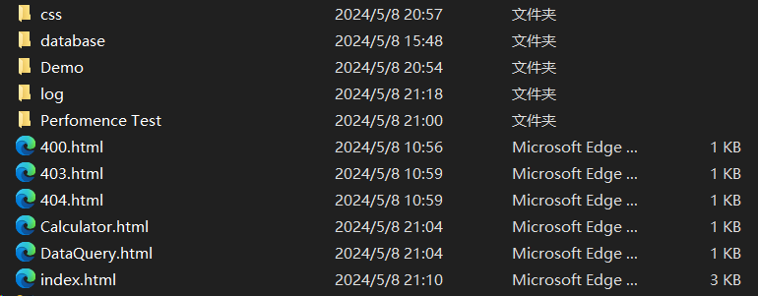

**CSS Design:**

CSS is a language that can add various styles to structured documents. In this practice, I use CSS to render and unify the visual styles of the main web pages, including the calculator interface and database query interface.

**Code (partial):**

|  |
| --- |
| html, body, div, span, applet, object, iframe, h1, h2, h3, h4, h5, h6, p, blockquote, pre, a, abbr, acronym, address, big, cite, code, del, dfn, em, img, ins, kbd, q, s, samp, small, strike, strong, sub, sup, tt, var, b, u, i, dl, dt, dd, ol, nav ul, nav li, fieldset, form, label, legend, table, caption, tbody, tfoot, thead, tr, th, td, article, aside, canvas, details, embed, figure, figcaption, footer, header, hgroup, menu, nav, output, ruby, section, summary, time, mark, audio, video {  margin: 0;  padding: 0;  border: 0;  font-size: 100%;  font: inherit;  vertical-align: baseline;  }  article, aside, details, figcaption, figure, footer, header, hgroup, menu, nav, section {  display: block;  }  ol, ul {  list-style: none;  margin: 0;  padding: 0;  }  blockquote, q {  quotes: none;  }  blockquote:before, blockquote:after, q:before, q:after {  content: '';  content: none;  }  table {  border-collapse: collapse;  border-spacing: 0;  }  /* start editing from here */  a {  text-decoration: none;  }  .txt-rt {  text-align: right; /* text align right */  }  .txt-lt {  text-align: left; /* text align left */  }  .txt-center {  text-align: center; /* text align center */  }  .float-rt {  float: right; /* float right */  }  .float-lt {  float: left; /* float left */  }  .clear {  clear: both; /* clear float */  } |

**3.5 CGI**

**Calculator Testing:** Implemented in Python, this functionality reads input parameters and operators, performs calculations, modifies the template file, and returns the generated page to the Post thread.

**Input:** Parameters and operators (from form data)

**Output:** Result of calculation

**Retrieving numbers and operators:**

|  |
| --- |
| ini = sys.argv[1]  hostname = sys.argv[2]  port = sys.argv[3]  ini = ini.split("&")  a = ini[0].split("=")[1]  b = ini[1].split("=")[1]  c = ini[2].split("=")[1] |

**Determining operation type based on the operator and performing the calculation:**

|  |
| --- |
| if c == "mul":  res = res.replace("$c", "*")  res = res.replace("$res", str(float(a) * float(b)))  elif c == "div":  res = res.replace("$c", "/")  res = res.replace("$res", str(float(a) / float(b)))  elif c == "add":  res = res.replace("$c", "+")  res = res.replace("$res", str(float(a) + float(b)))  else:  res = res.replace("$c", "-")  res = res.replace("$res", str(float(a) - float(b))) |

**Outputting the result:**

|  |
| --- |
| res = res.replace("$hostname", hostname)  res = res.replace("$port", port)  print(res) |

**Database Query Testing:** Implemented in Python, this functionality queries a student database containing names, IDs, and classes. It supports queries based on these three attributes or any combination thereof.

**Input:** Query conditions

**Output:** Concatenated SQL statement and the results of executing the SQL statement

**Retrieving query conditions:**

|  |
| --- |
| ini = sys.argv[1]  hostname = sys.argv[2]  port = sys.argv[3]  ini = ini.split("&")  student_id = ini[0].split("=")[1]  student_name = ini[1].split("=")[1]  student_class = ini[2].split("=")[1] |

**Determining which query conditions are used:**

|  |
| --- |
| id_flag = 1  name_flag = 1  class_flag = 1  if student_id == "":  id_flag = 0  if student_name == "":  name_flag = 0  if student_class == "":  class_flag = 0 |

**Constructing the SQL statement based on the conditions:**

|  |
| --- |
| if id_flag == 0 and id_name == 0 and class_flag == 0:  pass  else:  sql += " where"  if id_flag == 1:  sql += " id = " + student_id  if id_flag == 0 and name_flag == 1:  sql += " name = '" + student_name + "' "  elif id_flag == 1 and name_flag == 1:  sql += " and name = '" + student_name + "' "  if id_flag == 0 and name_flag == 0 and class_flag == 1:  sql += " class = '" + student_class + "' "  elif class_flag == 1:  sql += " and class = \"" + student_class + "\" " |

**Executing the SQL statement:**

|  |
| --- |
| cursor.execute(sql) |

**Formatting and outputting the query results and SQL statement:**

|  |
| --- |
| with open("cgi-bin/query_res.html", "r", encoding="utf-8") as f:  for line in f:  res += line  student_data = ''  for student in data:  temp = "<tr>"  temp += "<th>" + str(student[0]) + "</th>"  temp += "<th>" + student[1] + "</th>"  temp += "<th>" + student[2] + "</th>"  temp += "</tr>\n"  student_data += temp  res = res.replace("$data", student_data)  res = res.replace("$message", sql)  print(res) |

**4.6 Log File**

The generation of the log file is handled in the server.py file. Each time server.py is executed, it signifies a server startup, and a log file for that run is generated. The log files are stored in the "log" directory, named using the current server host time plus ".txt":

|  |
| --- |
| now_time = time.localtime()  log_name = "log/" + str(now_time.tm_year) + "-" + str(now_time.tm_mon) + "-" + str(now_time.tm_mday) + "-" + str(now_time.tm_hour) + "-" + str(now_time.tm_min) + "-" + str(now_time.tm_sec) + ".txt"  thread_pool(log_name) |

Data for the log files comes from data received via *‘socket.recv()’*, stored in the *‘message’* variable, as follows:

|  |
| --- |
| message = self.socket.recv(1024).decode("utf-8")  message = message.splitlines()  self.msg = message |

An example of a received message (a GET request):

|  |
| --- |
| GET /css/img/birds.jpeg HTTP/1.1  Host: 192.168.92.1:8888  Connection: keep-alive  User-Agent: Mozilla/5.0 (Windows NT 10.0; Win64; x64) AppleWebKit/537.36 (KHTML, like Gecko) Chrome/106.0.0.0 Safari/537.36  Accept: image/avif,image/webp,image/apng,image/svg+xml,image/*,*/*;q=0.8  Referer: http://192.168.92.1:8888/  Accept-Language: zh-CN,zh;q=0.9  Accept-Encoding: gzip, deflate |

The process for handling messages is as follows:

|  |
| --- |
| content = self.msg[1].split(":")[1].replace(" ", "") # Get the host address  content = content + "--"  # Record the message time  content = content + "[" + str(time.localtime().tm_year) + "-" + str(time.localtime().tm_mon) + "-" + str(time.localtime().tm_mday) + "-" + str(time.localtime().tm_hour) + "-" + str(time.localtime().tm_min) + "-" + str(time.localtime().tm_sec) + "]"  content = content + " " + self.msg[0].split("/")[0].replace(" ", "") + " " # Request method  content = content + " " + self.msg[0].split(" ")[1].replace(" ", "") + " " # Requested URL  content = content + str(file_size) + " " # Size of data returned  content = content + str(self.status_code) + " " # Returned status code  for i in self.msg: # Referer address  if i.split(" ")[0] == "Referer:":  content = content + i.split(" ")[1].replace(" ", "")  content = content + "\n"  with open(self.log_name, "a") as f:  f.write(content) # Write back to the log file |

Using the above GET type message as an example, after processing the message to filter out the host address, access time, request method (GET, POST, or HEAD), the requested resource, and the return status code, the following log information is obtained:

|  |
| --- |
| 192.168.56.1--[2022-9-29-16-41-15] GET /css/img/birds.jpeg 147048 200 http://192.168.56.1:8888/ |

Finally, the resulting message is compared with the results captured using Wireshark, confirming the correctness of the log records.

1. **System Deployment, Startup, and Use**

**4.1 System Requirements:**

**Required Environment:** Python >= 3.6, Necessary Python Libraries: socket, threading, time, os, sys, queue, subprocess.

**Compilers Used:** VSCode or PyCharm;

**Invocation Method:** Using a compiler or command line invocation.

**4.2 System Startup:**

Command Line Invocation: In the webserver folder, open the command line and enter python *‘server.py’*, then input the maximum number of connections as shown below:

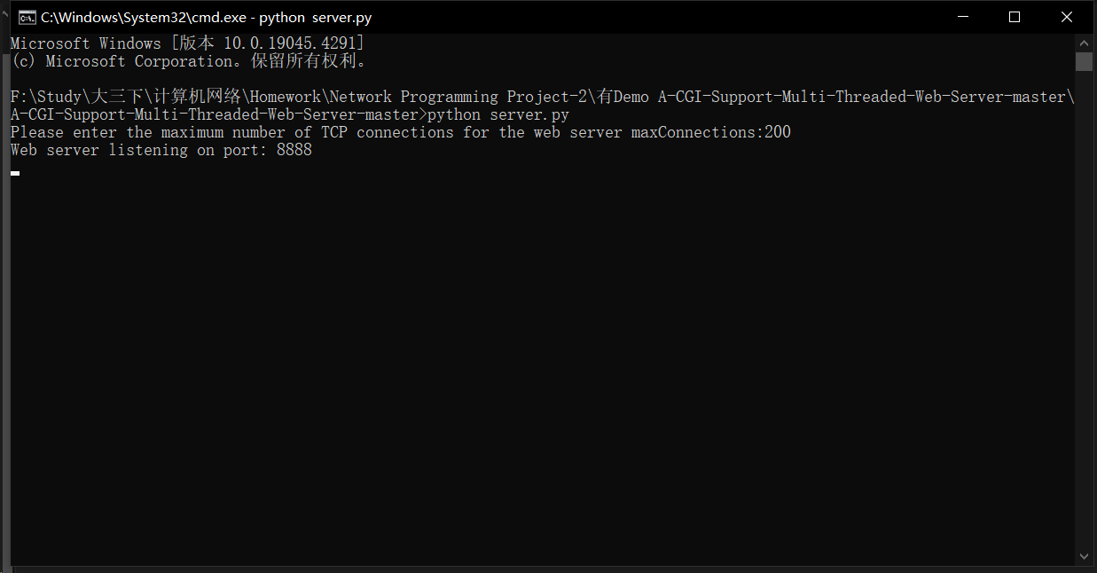

At this point, the multi-threaded server has been initiated. Compiler invocation: Run the server.py file using the compiler. Similarly, enter the maximum number of connections as required, and the multi-threaded server will start.

**4.3 How to Use the System**

After running, copy the IP address and port 'http://127.0.0.1:8888/' displayed in the prompt into your browser and open it. You will see the main interface as shown in the figure below:

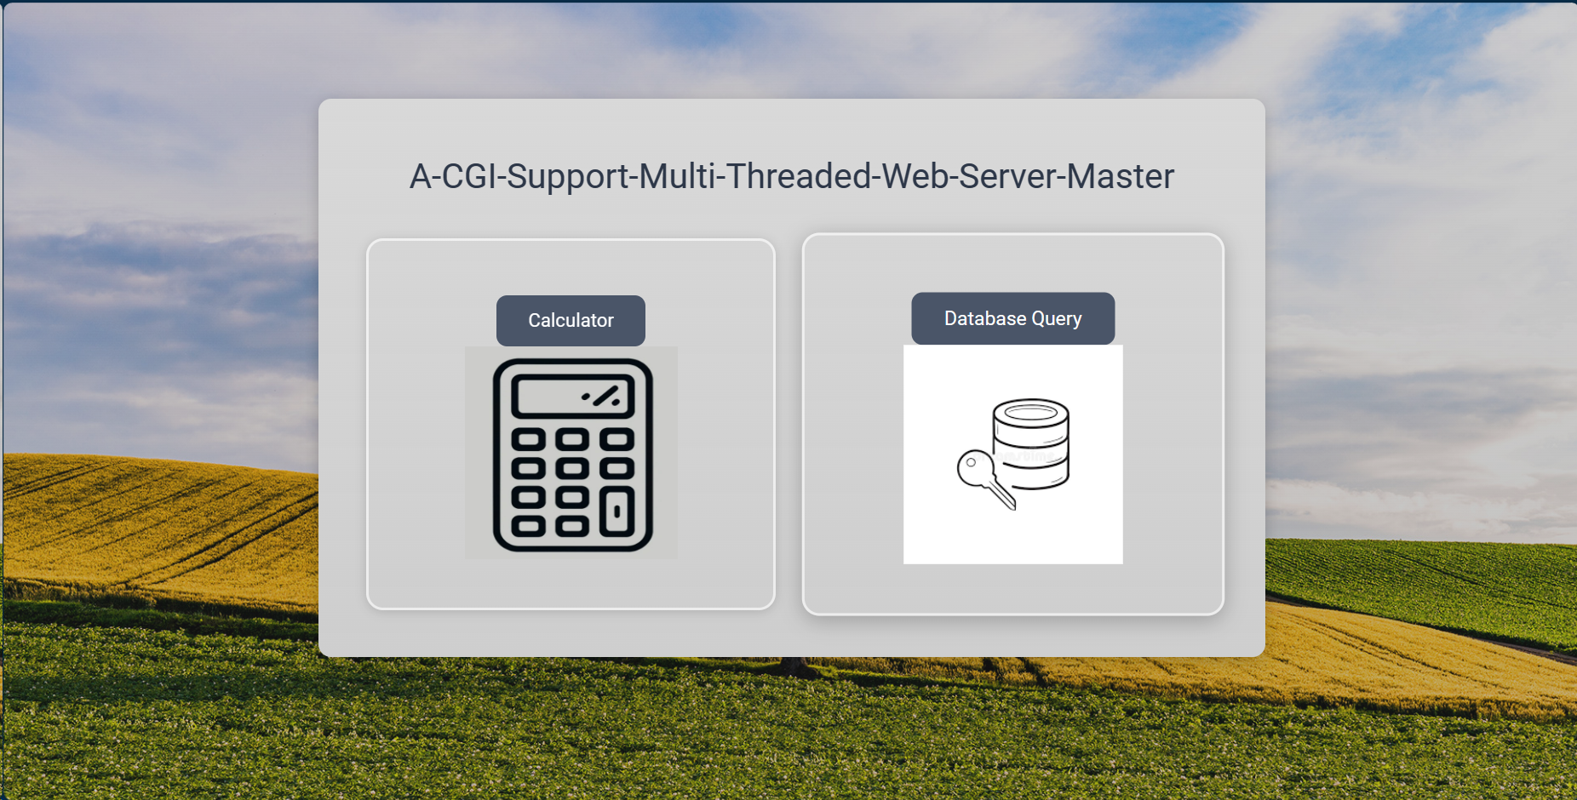

As shown in the image, by clicking the buttons on both sides, the CGI programs are invoked. The button on the left side is for the calculator. Enter the numbers and the calculation method as required to call the calculator program calculator.py, as shown below:

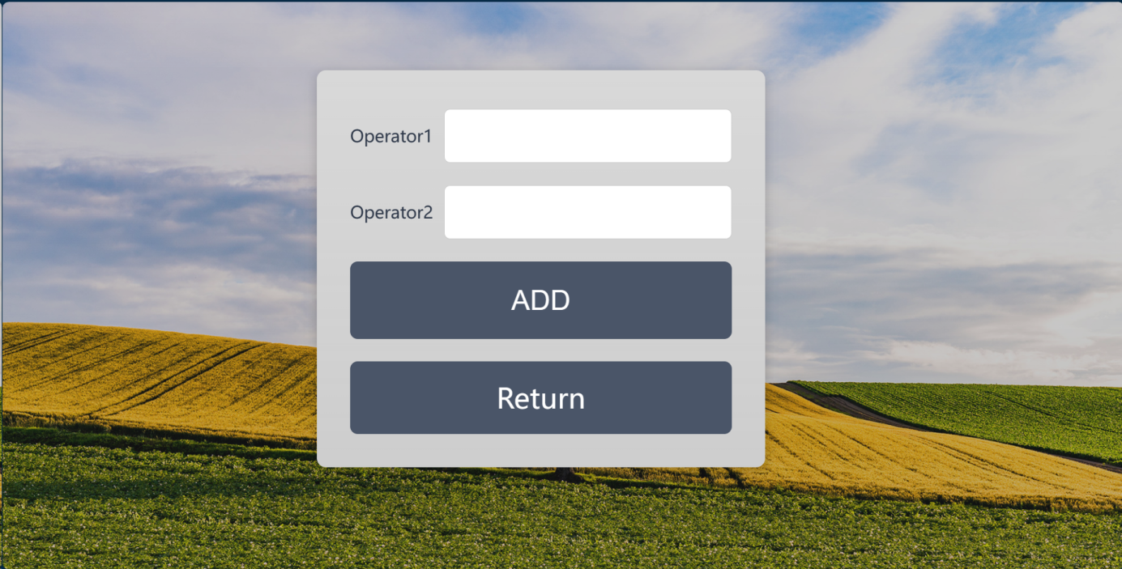

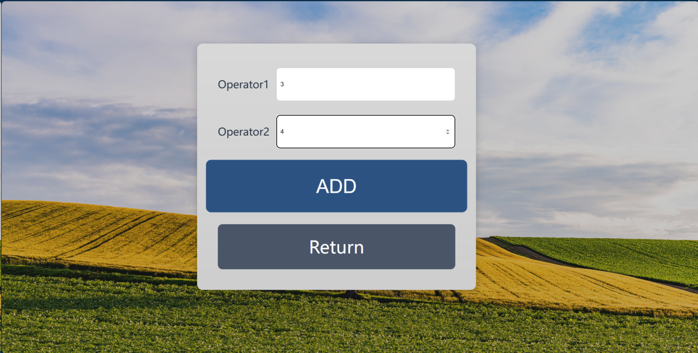

Enter two operands and click 'ADD' to execute. The specific results will be displayed on the results page.

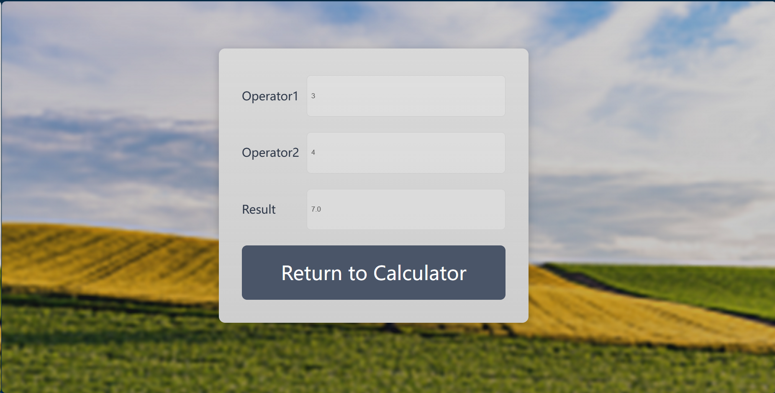

Click the query button on the right to search the student database. After clicking 'Submit', the query program query.py is invoked, as shown below:

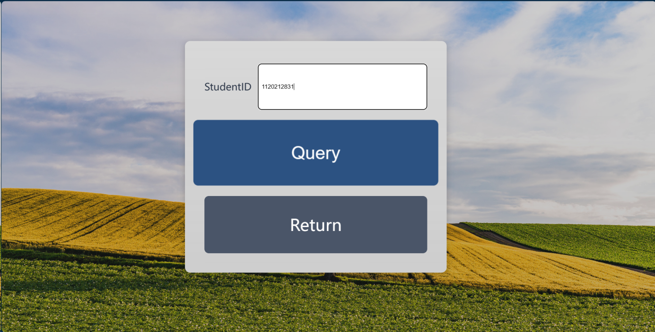

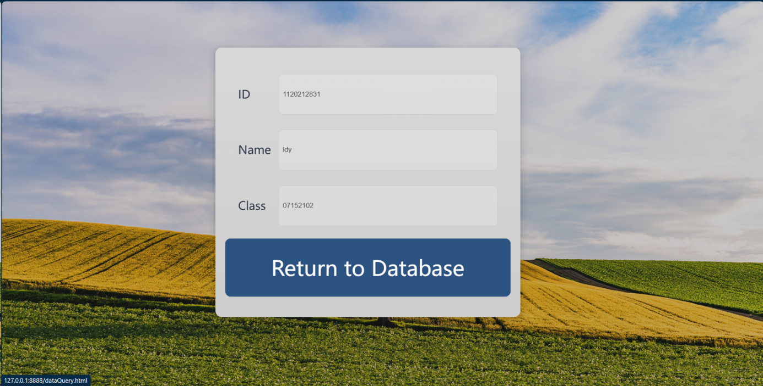

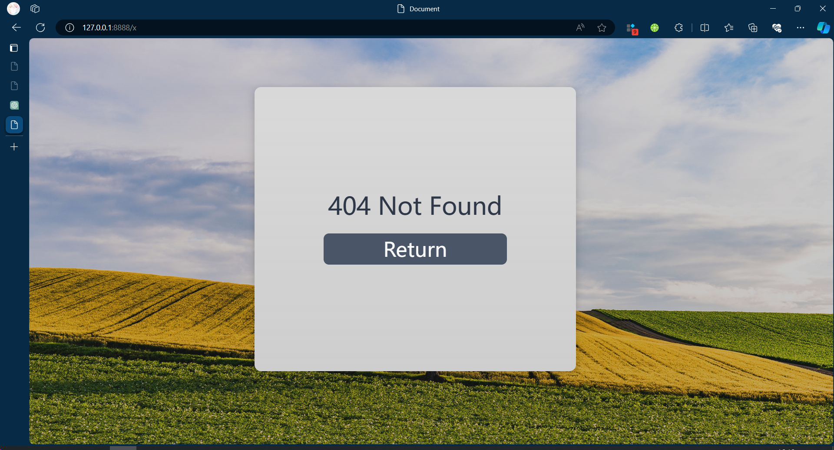

When an incorrect address is entered, you will be redirected to the '404 Not Found' page.

1. **System Test**

**5.1 Unit Test**

server.py: Responsible for the server's socket connections and invoking the thread pool. If the following message is received, it indicates that the message sending and receiving were successful. Moreover, if the server does not respond within the set time, a 'socket timeout' message will appear.

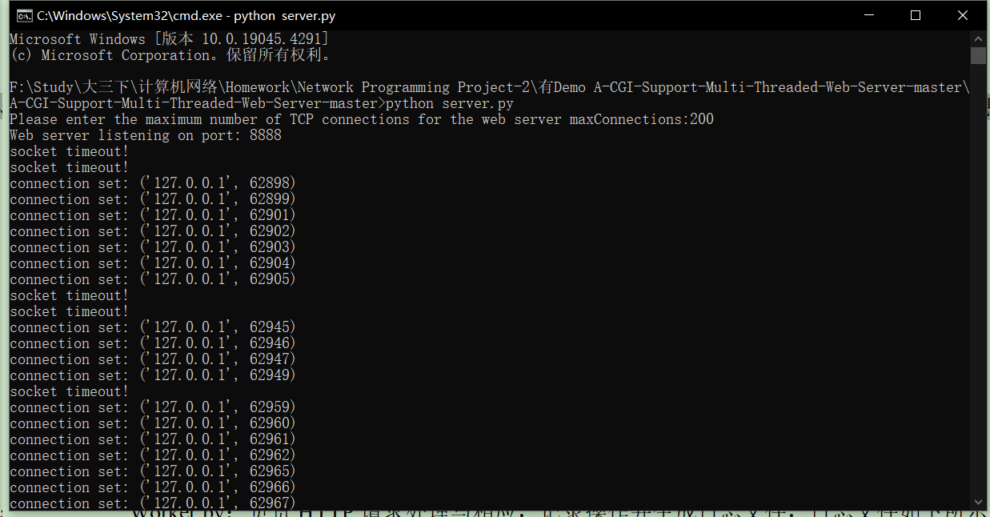

HTTPRequestHandler.py: Responsible for handling HTTP requests and responses, recording operations, and generating log files. The log files are shown below.

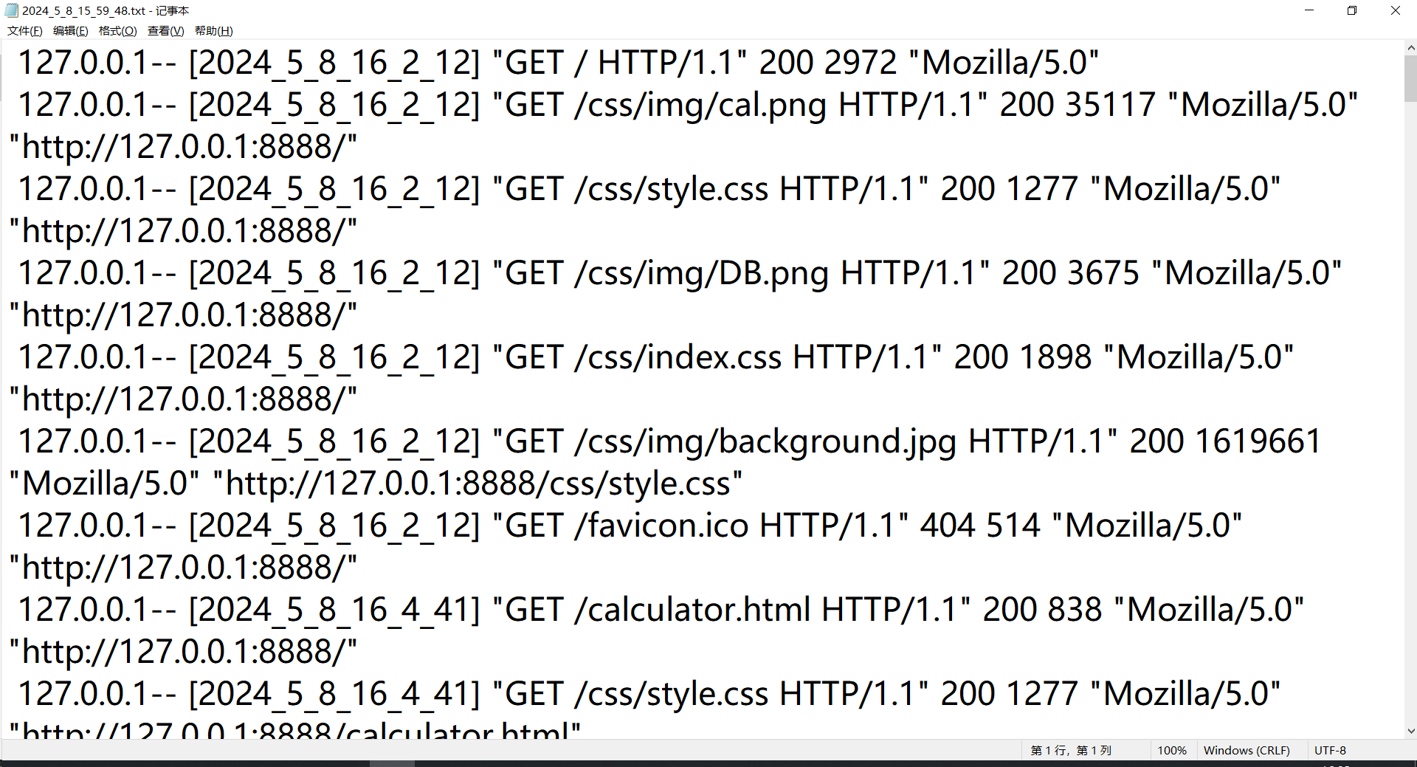

5.2 Integrated Test

The webpage is as follows:



When entering a non-existent URL, a '404 Not Found' message will appear, for example, when entering *<http://127.0.0.1:8888/x>* ：



For the calculator interface, if the input does not comply with the rules, a prompt will appear:

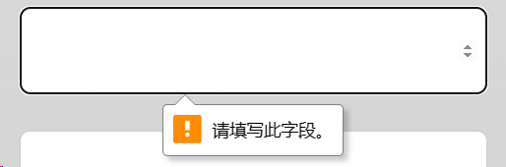

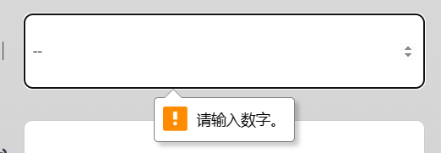

If the input is correct, it will redirect to the results page:



For the student information query interface, any number entered in the text box will work; if it matches student information in the database, the query results will display normally:

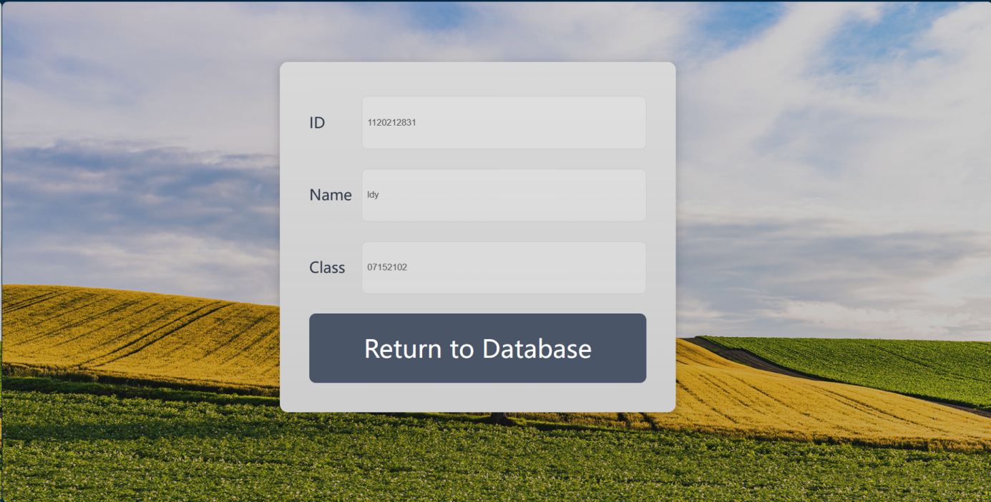

If there is no matching information, it will display 'Not Exist.':

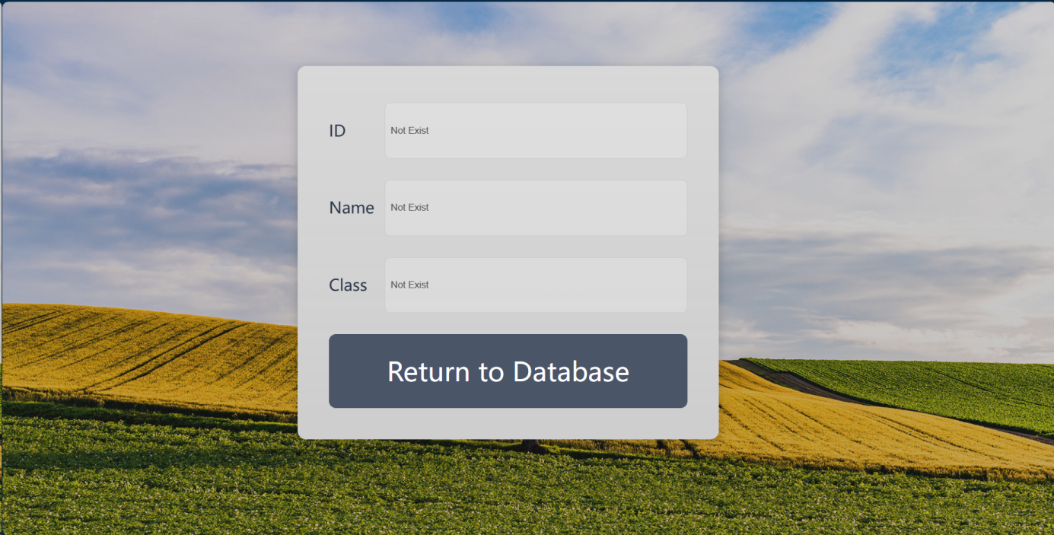

1. **Performance and Analysis**

For the multi-threaded server, I used stress and load testing software called K6. Running the test script test_script.js from the command line yields the results as shown below:

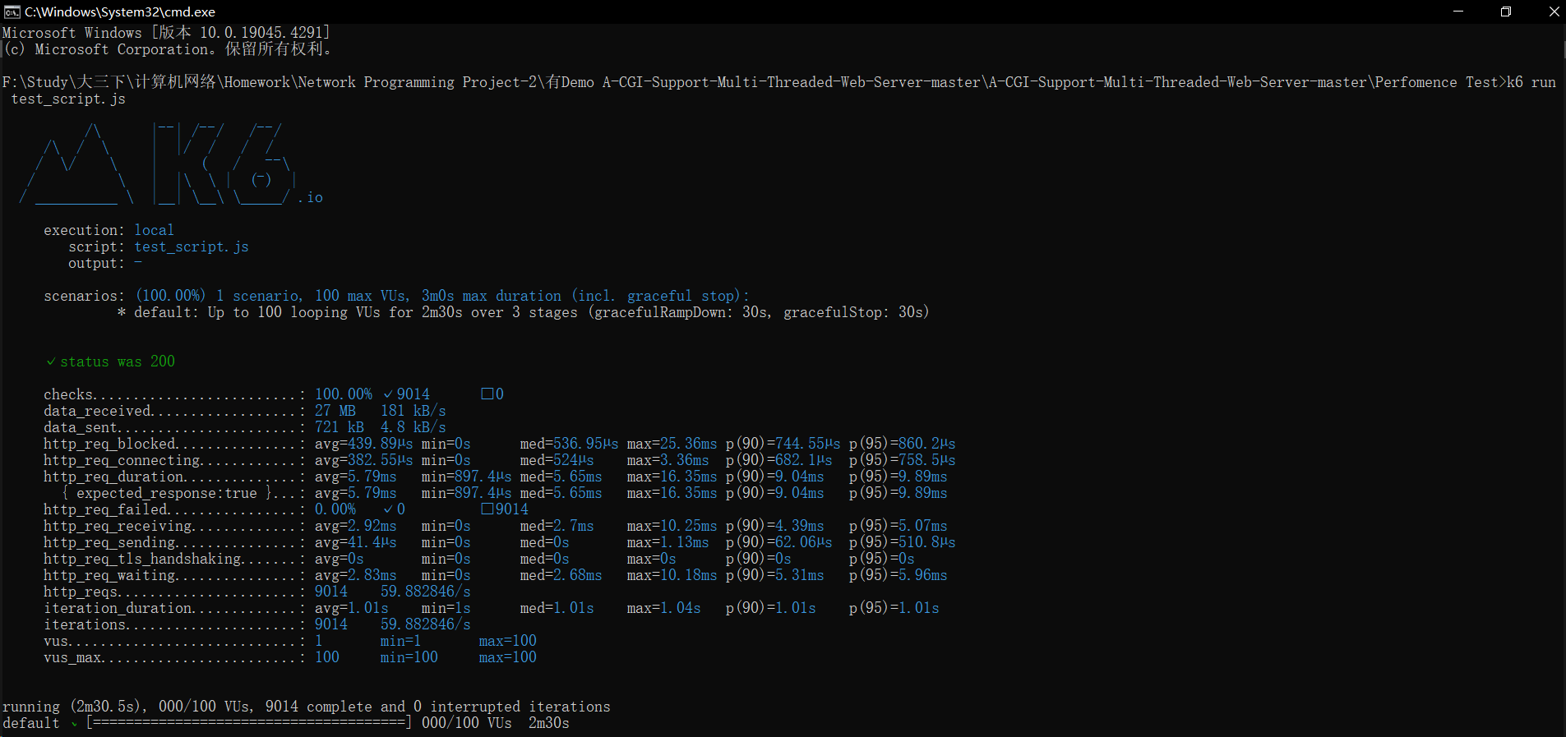

1. **Summary or Conclusions**

This project analyzed TCP Socket connections and HTTP GET, HEAD, and POST requests. By constructing a thread pool, I successfully built a multi-threaded server.

The CGI testing module was completed using Python, including components for a calculator and data queries, successfully facilitating the construction of both static and dynamic web pages.

Building a multi-threaded server helped deepen our understanding of TCP connections, HTTP protocol, and CGI program invocation. Additionally, the website underwent stress testing. The system performance is satisfactory, capable of handling 1,000 concurrent client accesses, and meets the requirements for simultaneous use by a small group of people.

1. **References**

1.**Stevens, W. Richard.** "UNIX Network Programming, Volume 1: The Sockets Networking API." Prentice Hall, 3rd edition, 2003. A comprehensive guide on network programming, including detailed discussions on TCP/IP socket programming.

2.**Fielding, Roy Thomas, et al.** "Hypertext Transfer Protocol—HTTP/1.1." RFC 2616, June 1999. Available: https://tools.ietf.org/html/rfc2616. This document specifies the HTTP/1.1 protocol, providing a foundation for web communication.

3.**Hughes, Michael.** "Parallel and Distributed Programming Using C++." Cambridge University Press, 2003. This book offers insights into developing applications that utilize multi-threading and socket programming effectively.

4.**Silberschatz, Abraham, Peter Baer Galvin, and Greg Gagne.** "Operating System Concepts." Wiley, 10th edition, 2018. This textbook includes information on process management and synchronization, crucial for understanding multi-threading and server design.

5.**Nginx Contributor Community.** "Beginner’s Guide." Nginx Documentation, 2020. Available: https://nginx.org/en/docs/beginners_guide.html. While primarily about Nginx, this guide offers useful insights into server management and handling HTTP requests which can be beneficial for CGI integration.

6.**Tilkov, Stefan, and Martin Eigenbrodt.** "REST and HTTP: The Definitive Guide." O'Reilly Media, 2015. This book provides a deep dive into HTTP methods and RESTful architectures, useful for designing web interfaces that interact with a server backend like CGI scripts.

1. **Comments**

This course provided me with a valuable experience in building a multi-threaded web server. By implementing a CGI-supported multi-threaded web server, I gained an in-depth understanding of networking concepts such as the TCP/IP protocol stack, multi-threaded programming, and the HTTP protocol. This project not only reinforced the course knowledge but also cultivated my programming skills and system design thinking.

However, I do have a few suggestions:

1. More advanced features could be added, such as support for HTTPS, compressed transmission, etc., to make the project more practical.
2. Provide more detailed coding guidance and debugging techniques to help students complete the project more efficiently.
3. Consider using a more advanced concurrent programming model, such as asynchronous I/O, to improve server performance.

Overall, this is an excellent hands-on project that has benefited me greatly. With continuous improvement, I believe this project could provide an even better learning experience for students.